**Development of a map display for Niwa modelled data in Deltares-** (Ude Shankar,15May2020)

A method utilising a modified Deltares “Volume” model (available through the demo version), together with coding within an IronPython script has enabled map display of modelled data in Niwa’s interoperable system, operating within Deltares GUI.

To view this version of the interoperable model login to the server in Hamilton and follow these instructions:

1. Open a command terminal, AKA a “DOS prompt,” by launching “cmd”. (**this has to be done as useradmin).**
2. From the terminal, run “C:\Models\Programs\ModelsEnv.bat”. (I use the tab button to auto-complete the command.)
3. You should see a new command prompt that looks like ”(Models) C:\Users\[your ID]>”. The (Models) part is created by the Anaconda environment, which is needed to run several of our models.
4. To launch DeltaShell, type “deltashell.gui” at the prompt.
5. Click the “tools” tab in the right hand panel.
6. Click on the “Scripts” > “Libraries” item. You will see “VolumeModelScript”.
7. Load the script.
8. Ecotope model output netcdf file is referenced there, and so is the model variable you want displayed (currently “ecotope_fast_flow”). They can be modified to suit.
9. Press ctrl-enter to start the process.
10. Click on the Map “view” on the “Open with” window and you will see a map of the Aparima catchment.

1. Select the “Map” tab on the r-h panel. Turn off “Drainage basin” and turn on “Niwa_model_value”. You will see the map coloured by the values for each catchment. Change the colour scheme by clicking on properties and choose a new gradient colour scheme as below:

1. Map below shows modelled values of ecotope_fast_flows.

The animation below shows changes in fast flow with time in each of the catchments:



1. Time series plots within each catchment can also be made by selecting individual catchments and clicking “Query Time Series”.

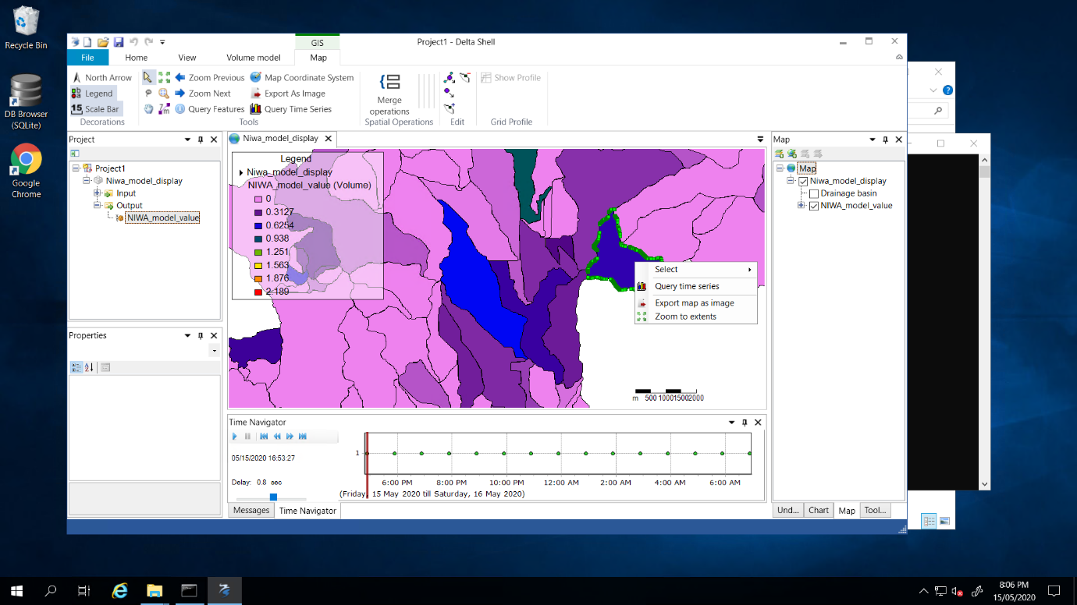

1. To enable plots for other variables, for example groundwater recharge, or gw flow, simply replace the variable name in the python script,

for eg.

# place name of Niwa model variable here.

gflow = file.Read(file.GetVariableByName("ecotope_ groundwater_recharge")),

or

gflow = file.Read(file.GetVariableByName("ecotope_gw_flow").

Next press ctrl-enter.